Daniel Moctezuma

Edgar Gangware

Pete Surowka

CS-425

Professor Hong

Jos A Bank – Final Report

1. 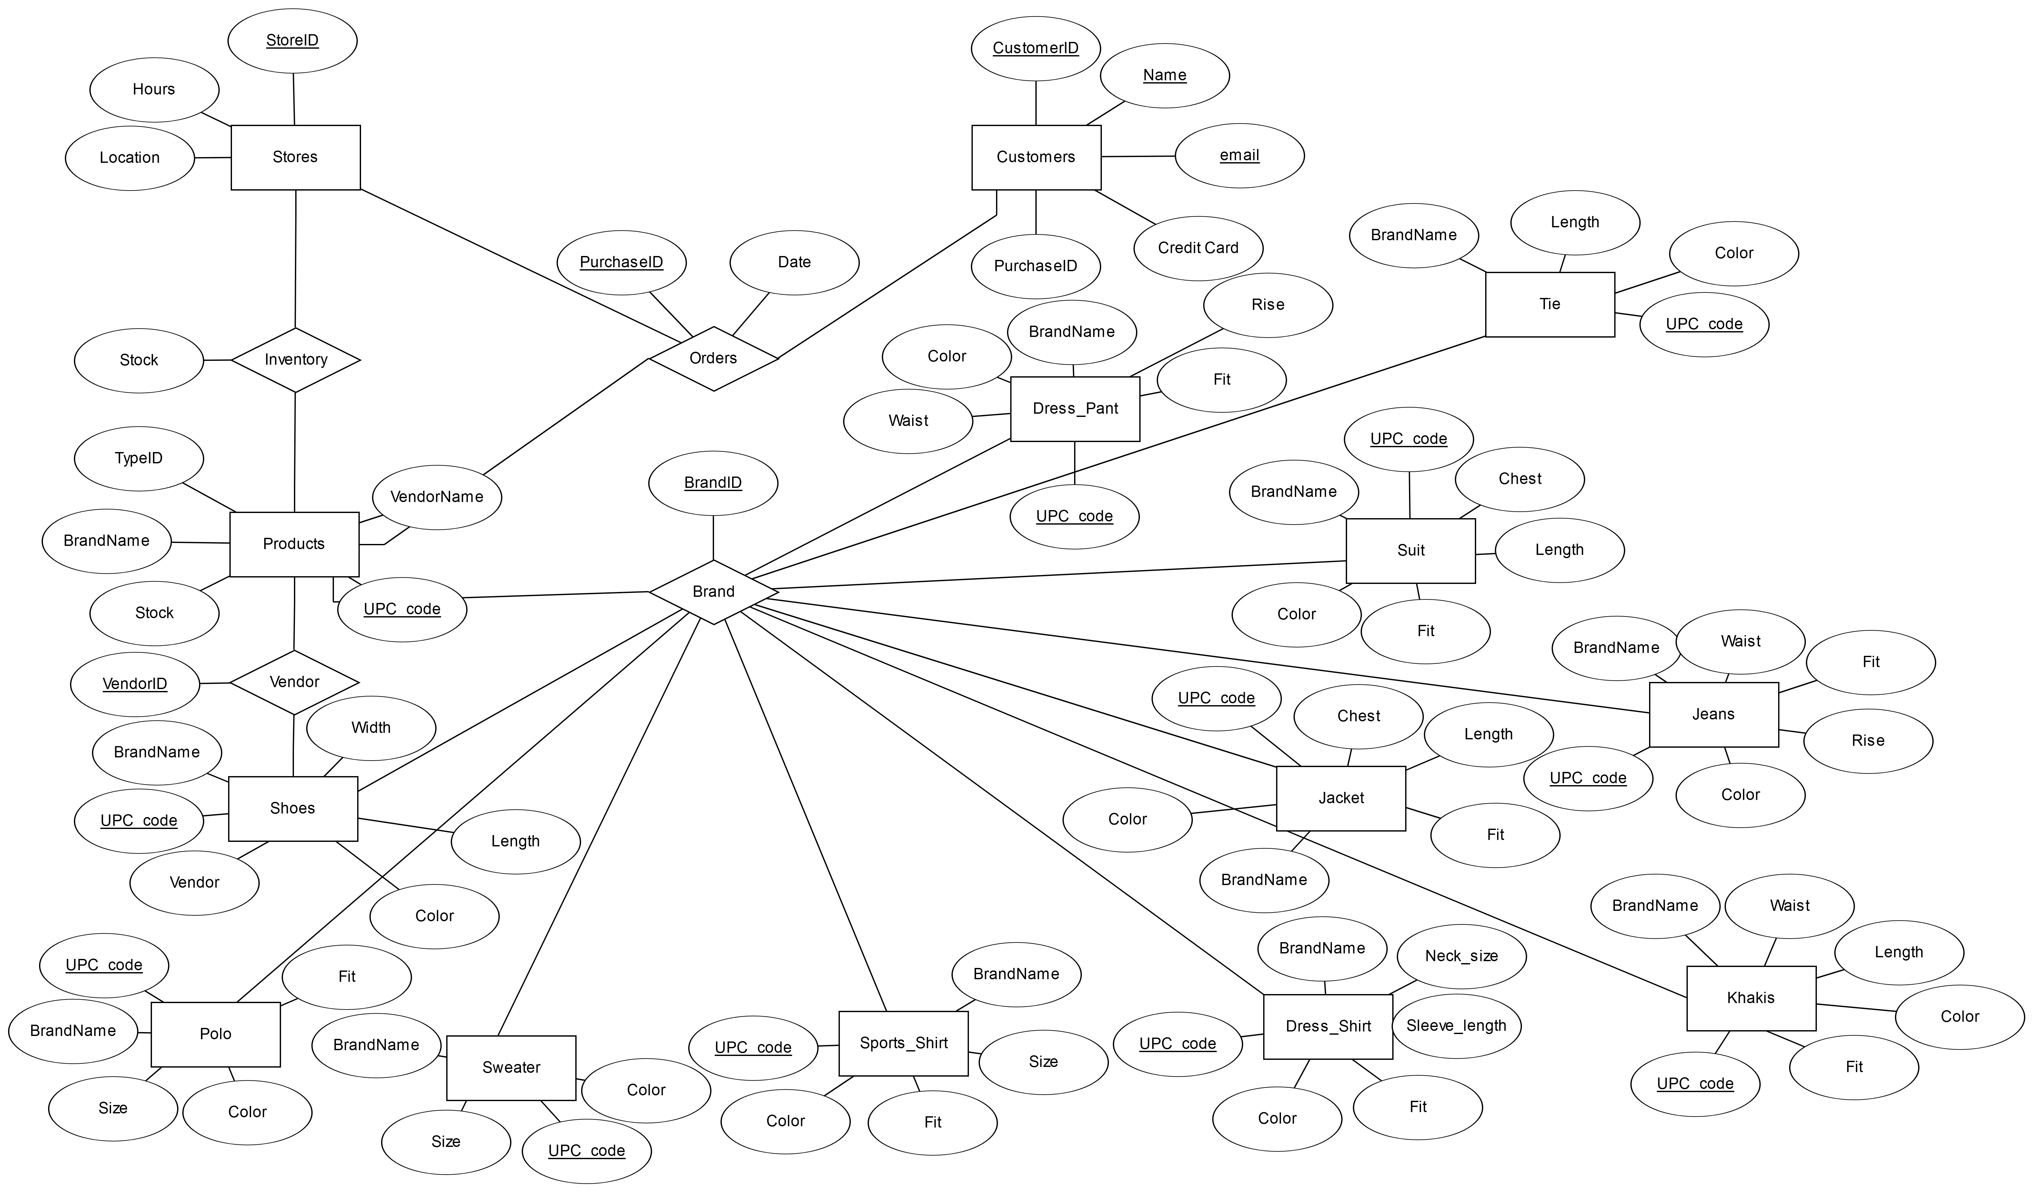ERD DIAGRAM
2. SCREEN SHOTS











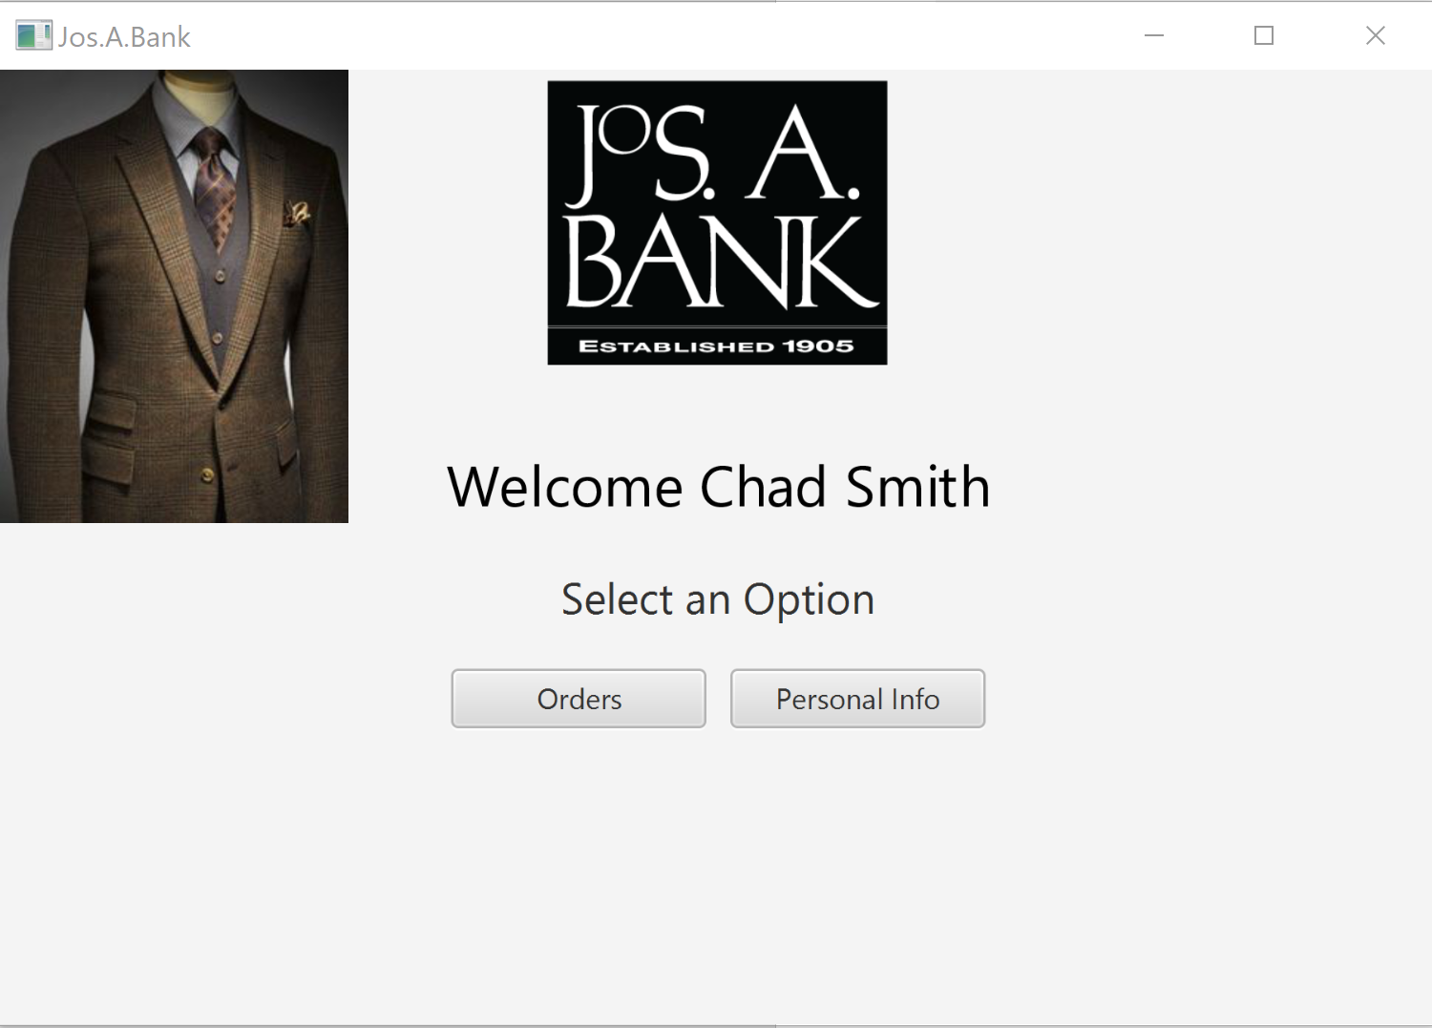

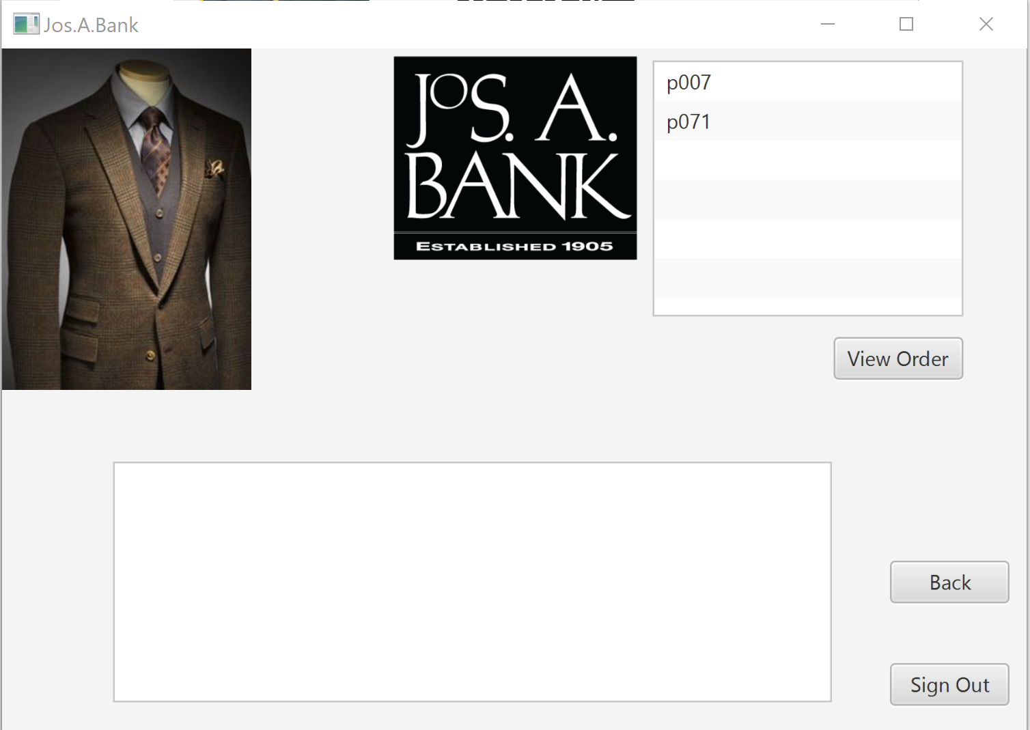

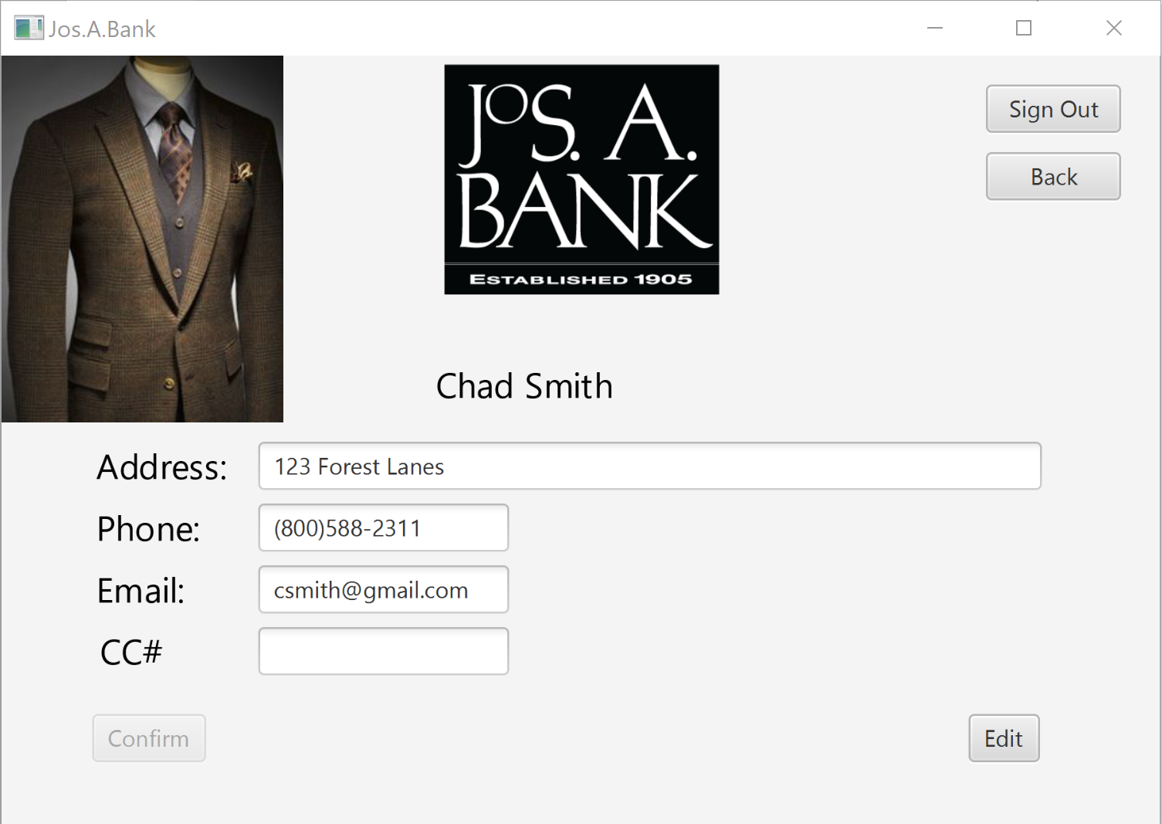

1. STUDENT CONTRIBUTION

Daniel Moctezuma – Daniel was the leader architect and programmer of the assignment. He was responsible for putting together the code, the UI, and testing. He also served as group leader and scheduled meetings and made all final decisions.

Edgar Gangware - Eddie was responsible for designing the SQL queries that were placed in strings in Daniel’s code. Additionally, he architected the original SQL script, compiled the report, did testing, and worked on parts of the Java that went into the final application.

Pete Surowka – Peter wrote SQL scripts and constructed the ERD diagram. He was the architect behind the database structures and what relations went into the table and what their relationships were. Peter also ran testing on the finished project. Additionally, he populated the whole database.

1. SOURCE CODE

Please see blackboard and corresponding project.zip file for the project’s source code. The code is written in Java and uses scripted SQL statements and JavaFX graphics library for the UI. The java code has nested queries to set up the database. The prepared statements were inserted using java JBDC.